**a)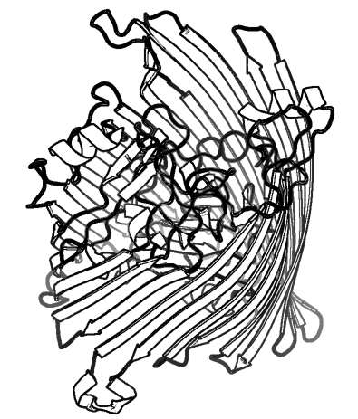b)**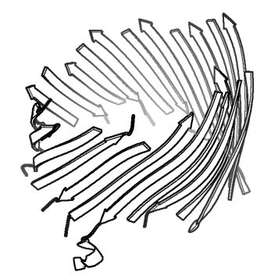

**a)** Outer membrane protein FecA (PDB 1KMO). **b)** A model of FecA including only the residues predicted to be part of transmembrane strands by ProfTMB.